Calculator Challenge

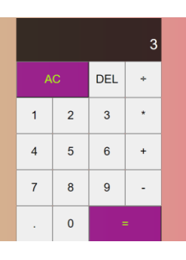 <div class="calculator-grid">

<div class="output">

<div class="previous-operand"></div>

<div class="current-operand"></div>

</div>

<button class="span-two">AC</button>

<button>DEL</button>

<button>÷</button>

<button>1</button>

<button>2</button>

<button>3</button>

<button>\*</button>

<button>4</button>

<button>5</button>

<button>6</button>

<button>+</button>

<button>7</button>

<button>8</button>

<button>9</button>

<button>-</button>

<button>.</button>

<button>0</button>

<button class="span-two">=</button>

</div>

The output class represents the calculator screen. The previous-operand represents the result of the previous operation in the calculator, while the current-operand class represents the current operation on the calculator.

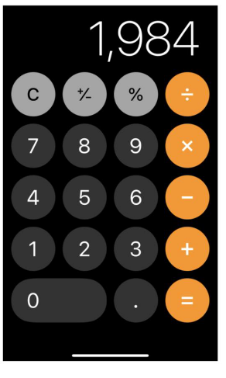 <div class="calculator-grid">

    <div class="output">

      <div class="previous-operand"></div>

      <div class="current-operand"></div>

  </div>

  <button>C</button>

  <button>+/-</button>

  <button>%</button>

  <button>÷</button>

  <button>7</button>

  <button>8</button>

  <button>9</button>

  <button>x</button>

  <button>4</button>

  <button>5</button>

  <button>6</button>

  <button>-</button>

  <button>1</button>

  <button>2</button>

  <button>3</button>

  <button>+</button>

  <button class="span-two">0</button>

  <button>.</button>

  <button>=</button>

  </div>